**Software Engineering course Project**

**AKFA University**

**Software Design Specification (SDS)**

**For**

**“UzWallet”**

Version **________________**

Timur Urunbaev

Bobir Ibragimov

Elbek Erkinboev

Ravshan Zaripov

Asadbek Fazliddinov

Samandar Kambaraliev

Muhammad Irshad-Nazeer

21-12-2022

| Project Code | Not applicable |
| --- | --- |
| Supervisor | Muhammad Irshad-Nazeer |
| Project Manager | Timur Urunbaev |
| Project Team | Samandar Kambaraliev  Ravshan Zaripov  Asadbek Fazliddinov  Elbek Erkinboev  Bobir Ibragimov |
| Submission Date | 21-12-2022 |

**1 Document Management** **2**

1.1 Contributors 3

1.2 Version Control 3

**2 Overview** **4**

**3 Development Tools And Standards** **4**

3.1 Development Tools 4

3.2 Development Standards 4

**4 System Processes** **4**

**5 User Interfaces** **4**

5.1 Transactional Interface 5

5.2 Reporting Interface 5

**6 Application Security** **5**

6.1 Authentication 5

6.2 Authorisation 5

6.3 Business Objects 5

**7 Database Design** **5**

**8 Application Interfaces** **5**

**9 Data** **5**

9.1 Data Migration 5

9.2 Archiving Policy 5

**10 Implementation** **5**

# 

# 1 Document Management

*When completing this document, please mark any section that is not required as ‘N/A’. A brief description of why the section is not required should also be included.*

## 1.1 Contributors

*Please provide details of all contributors to this document.*

| Role in our company | Unit | Name |
| --- | --- | --- |
| System Analyst Designer (Owner) |  | Muhammad Irshad-Nazeer |
| Business Analyst |  | Kambaraliev Samandar |
| Project Manager |  | Urunbaev Timur |
| Project Sponsor |  | Ibragimov Bobir |
| Business Area Manager |  | Zaripov Ravshan |
| Lead Tech Developer |  | Fazliddinov Asadbek |
| Designer |  | Erkinboev Elbek |

## 1.2 Version Control

*Please document all changes that made to this document since document distribution.*

| Date | Version | Author | Section | Amendment |
| --- | --- | --- | --- | --- |
| 10.12.2022 | 1.0 | U. Timur | docs | Created new repository |
| 10.12.2022 | 1.1 |  |  |  |
| 10.12.2022 | 1.2 |  |  |  |
|  |  |  |  |  |
|  |  |  |  |  |

# 

# 2 Overview

This product simulates a cardholder, where we keep our discount, membership, or loyalty cards. The application will keep all your LC on your smartphone and have access to them at any time. Also, users can open a new LC by choosing any store which provides a loyalty program. The feature will be implemented using the profile information, sending user credentials directly to issuing store. Moreover, advertisements and promotions appear in these stores, and users will be notified if they subscribe and turn on notifications.

* Template Application (Кошелек)
* Determine style and pattern
* Hardware + Software communications
* How system works

Architecture Pattern - MVC

Architecture Style -

Layers:

* Presentation Layer (UI/UX)
* Business Layer (Security, Data caching, logging, data validation, exception management)
* Data Layer (Persistence [API], Network)

# 3 Development Tools And Standards

## 3.1 Development Tools

* Language: Dart + Flutter framework
* Data Base: MySQL
* API platform: Postman
* Version control: Git, Github
* Design Tool: Figma

## 3.2 Development Standards

Standards being followed for this application.

**Standards:**

* Database Design
* Flutter
* Postman
* Accessibility
* Web Style Standards
* Supported Web Browser

# 4 System Processes

# 

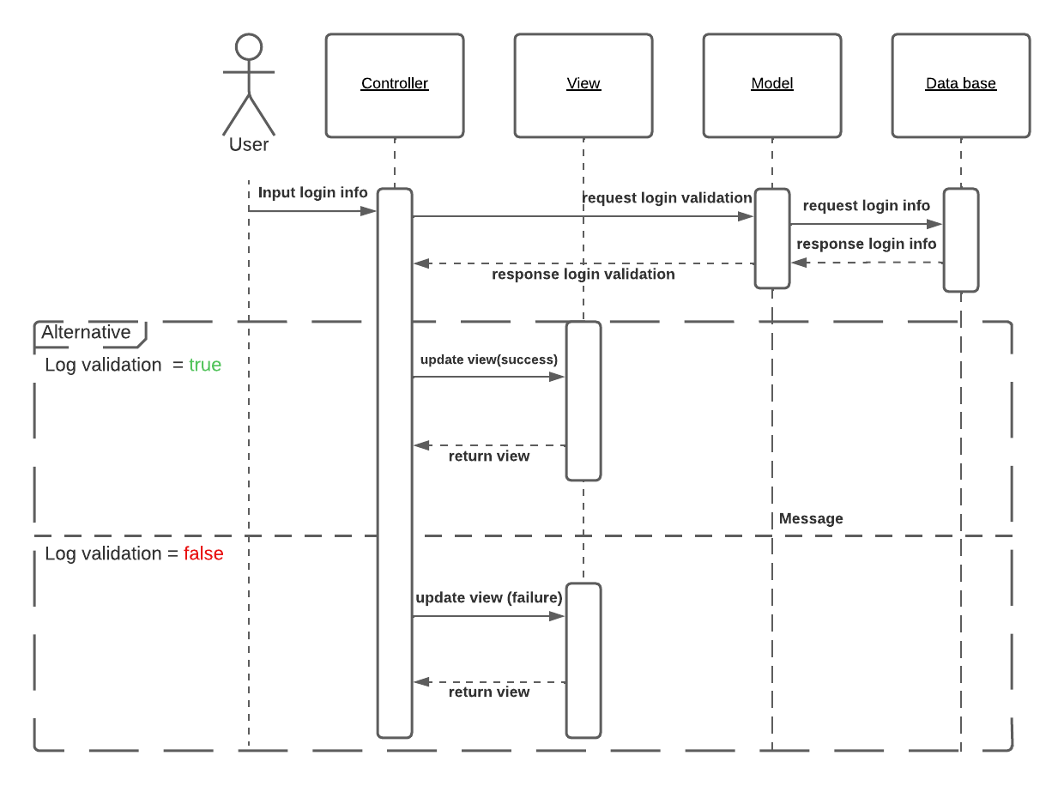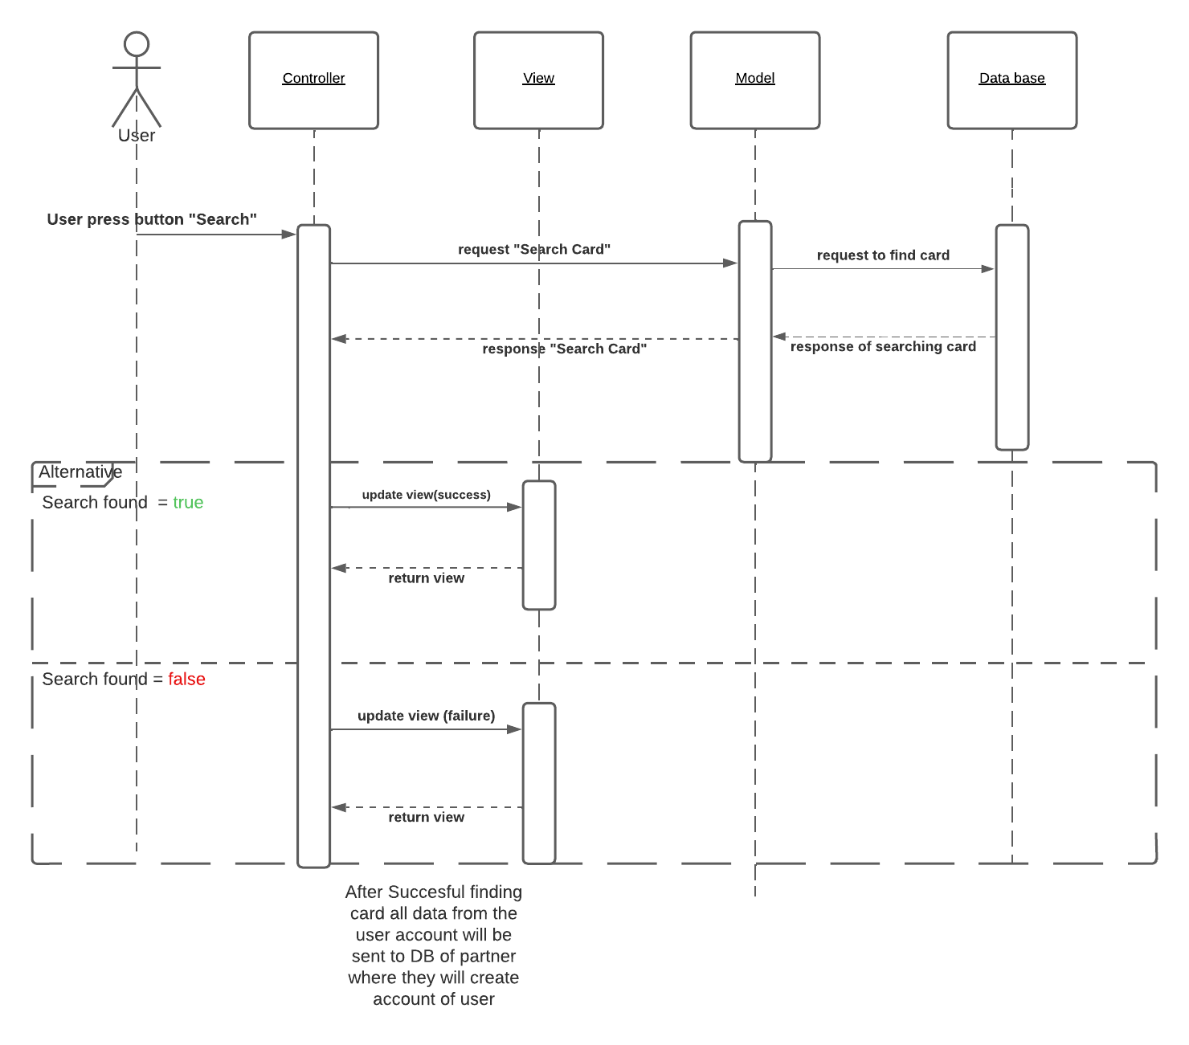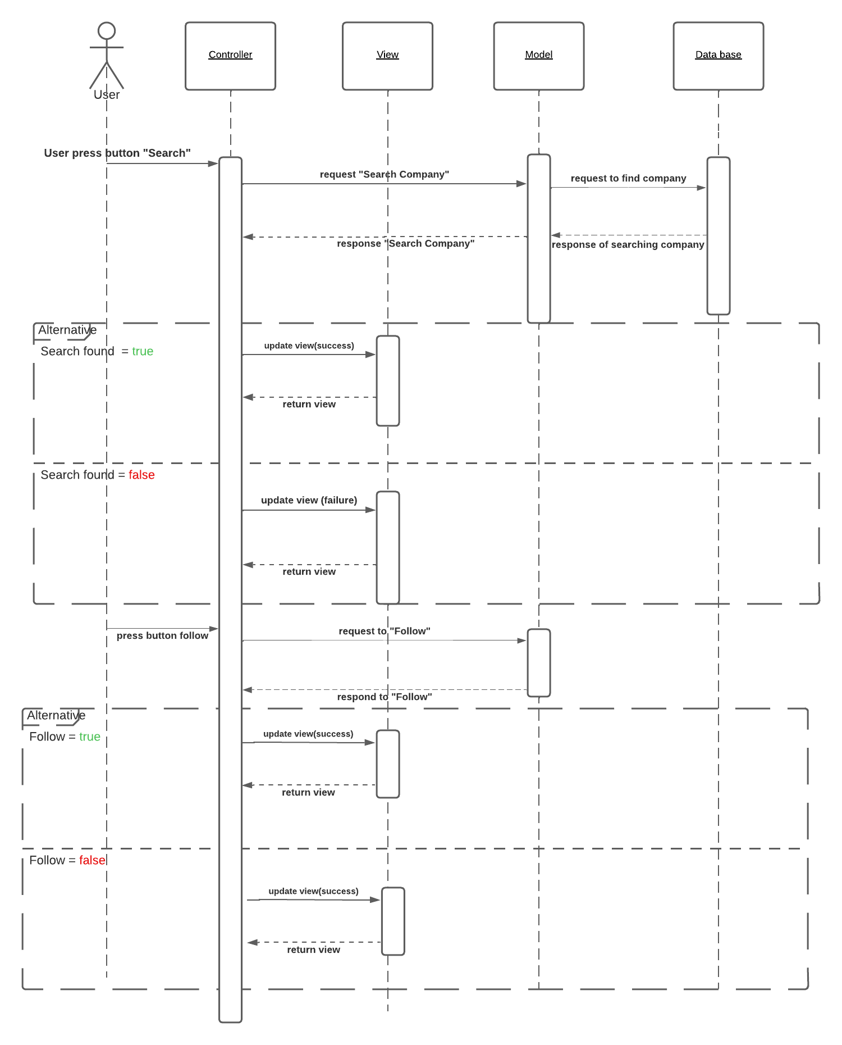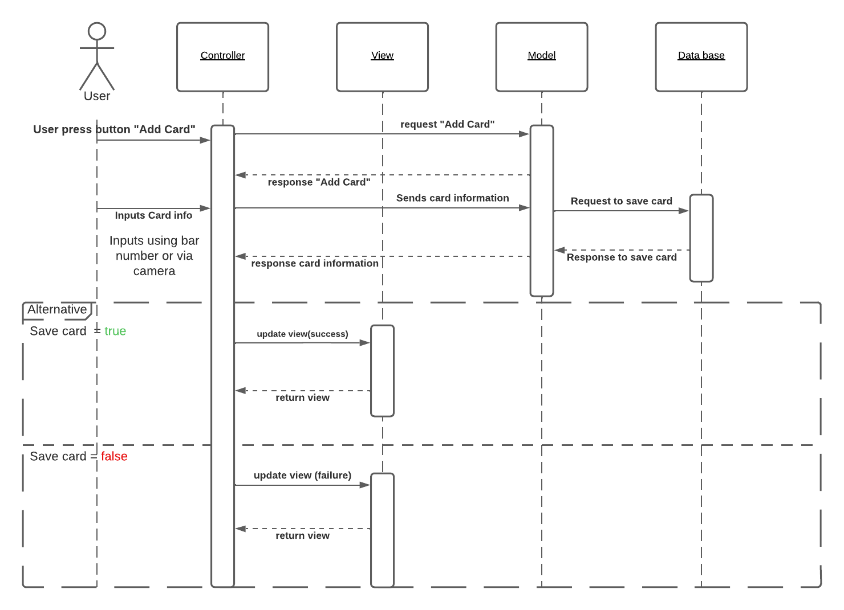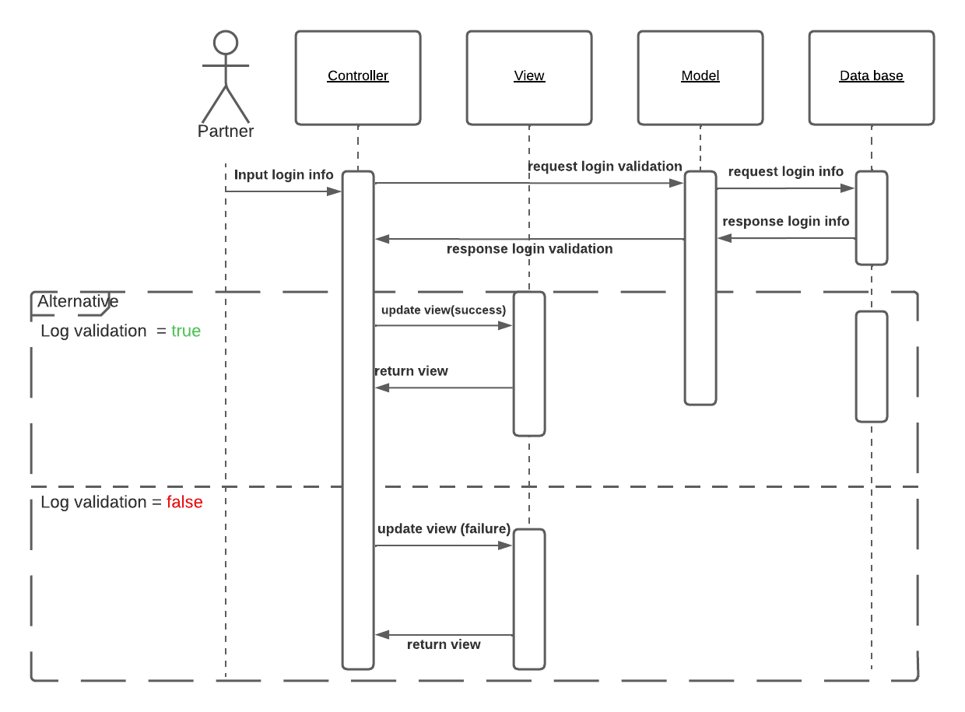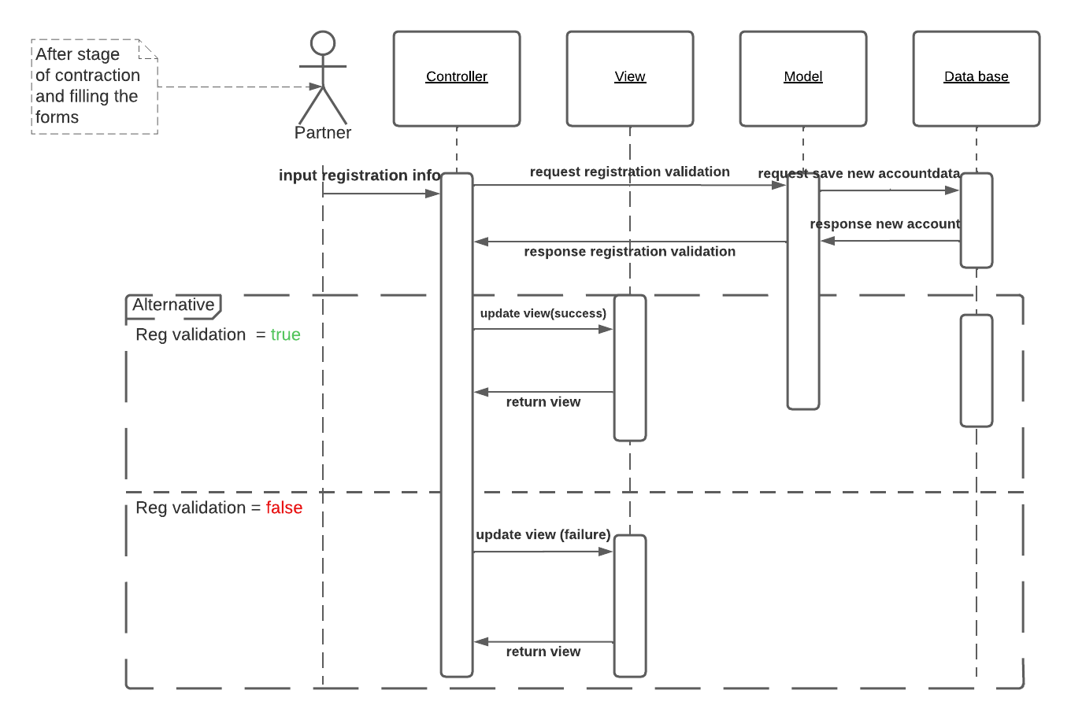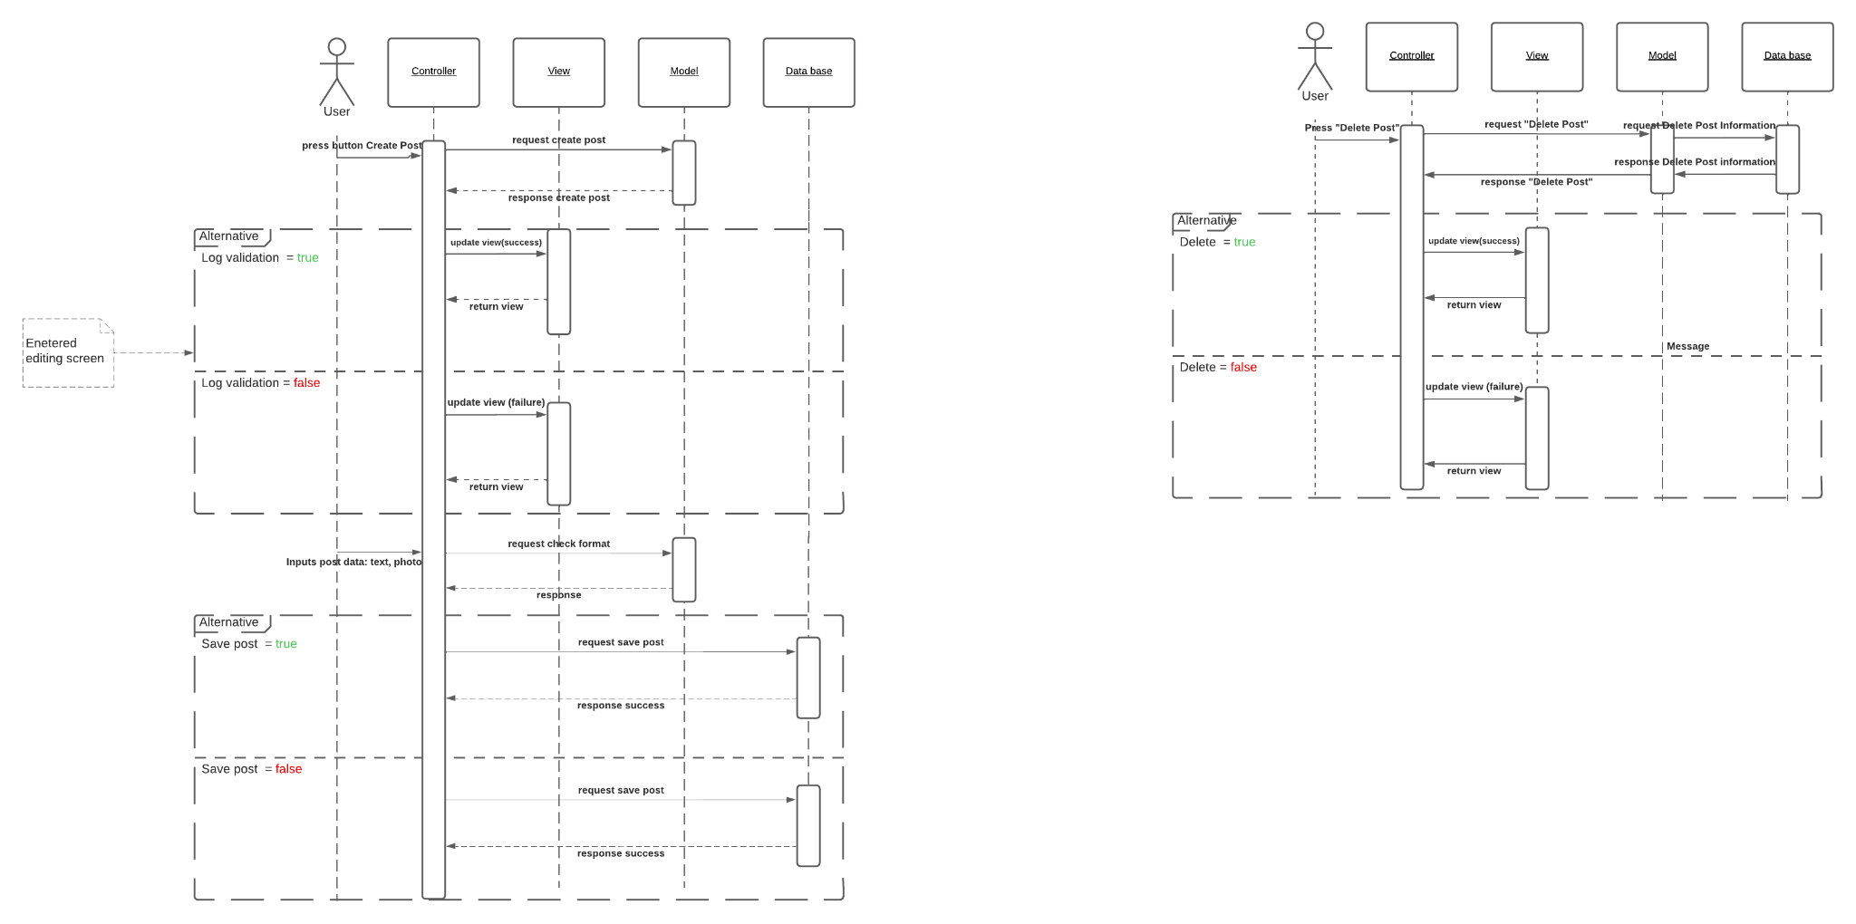

# 

# 5 User Interfaces

## 5.1 Transactional Interface

## 5.2 Reporting Interface

# 6 Application Security

## 6.1 Authentication

By default, MySQL uses the built-in mysql_native_password authentication plugin, which performs authentication using the native password hashing method.

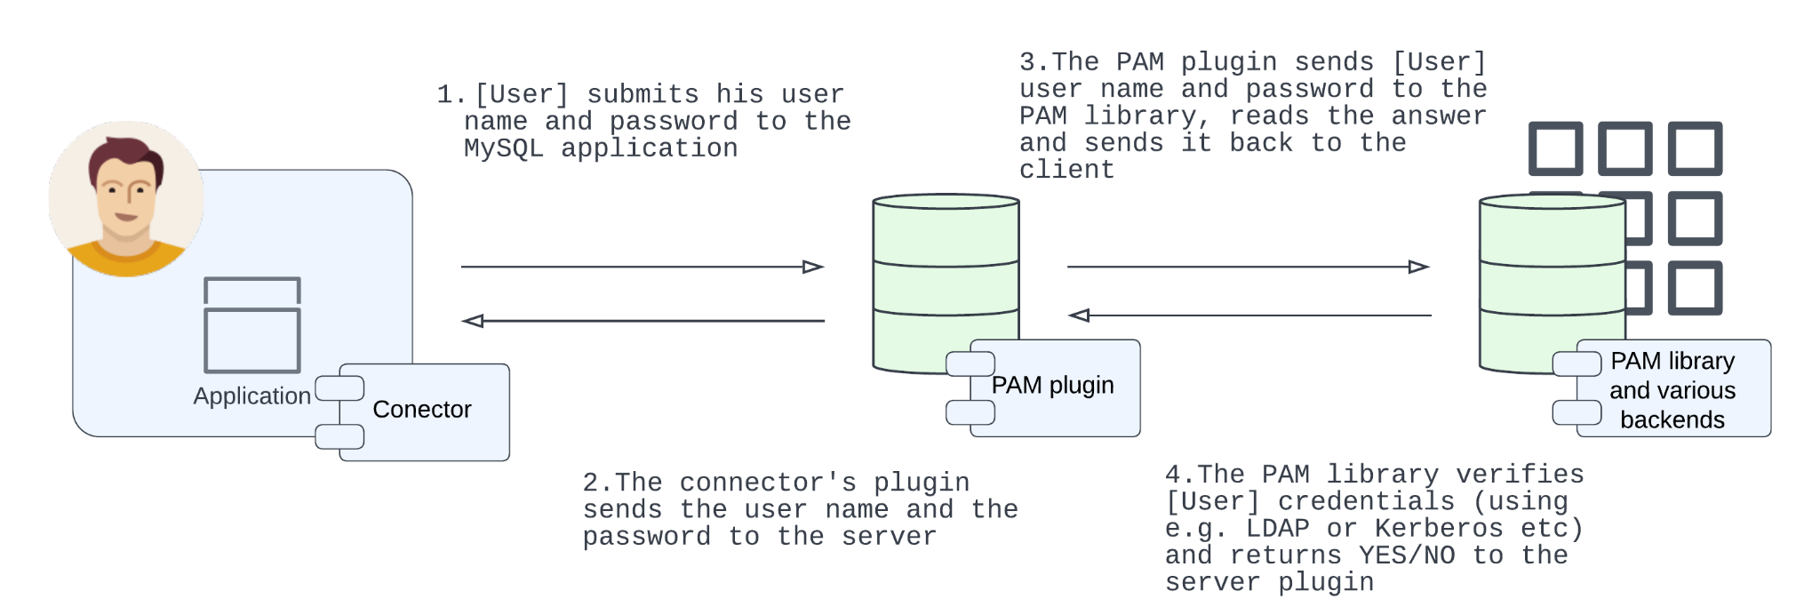

## 6.2 Authorisation

Once a client's credentials are authenticated, MySQL establishes a connection and then enters the second part of the access control system to determine authorization. MySQL authorization is an ongoing process that checks each command against the user account's specific privileges. If the commands fall within the scope of the user's privileges, the action is allowed. If not, the server denies the request.

## 6.3 Business Objects

# 7 Database Design

**7.1 Entity-Relationship Diagram of system**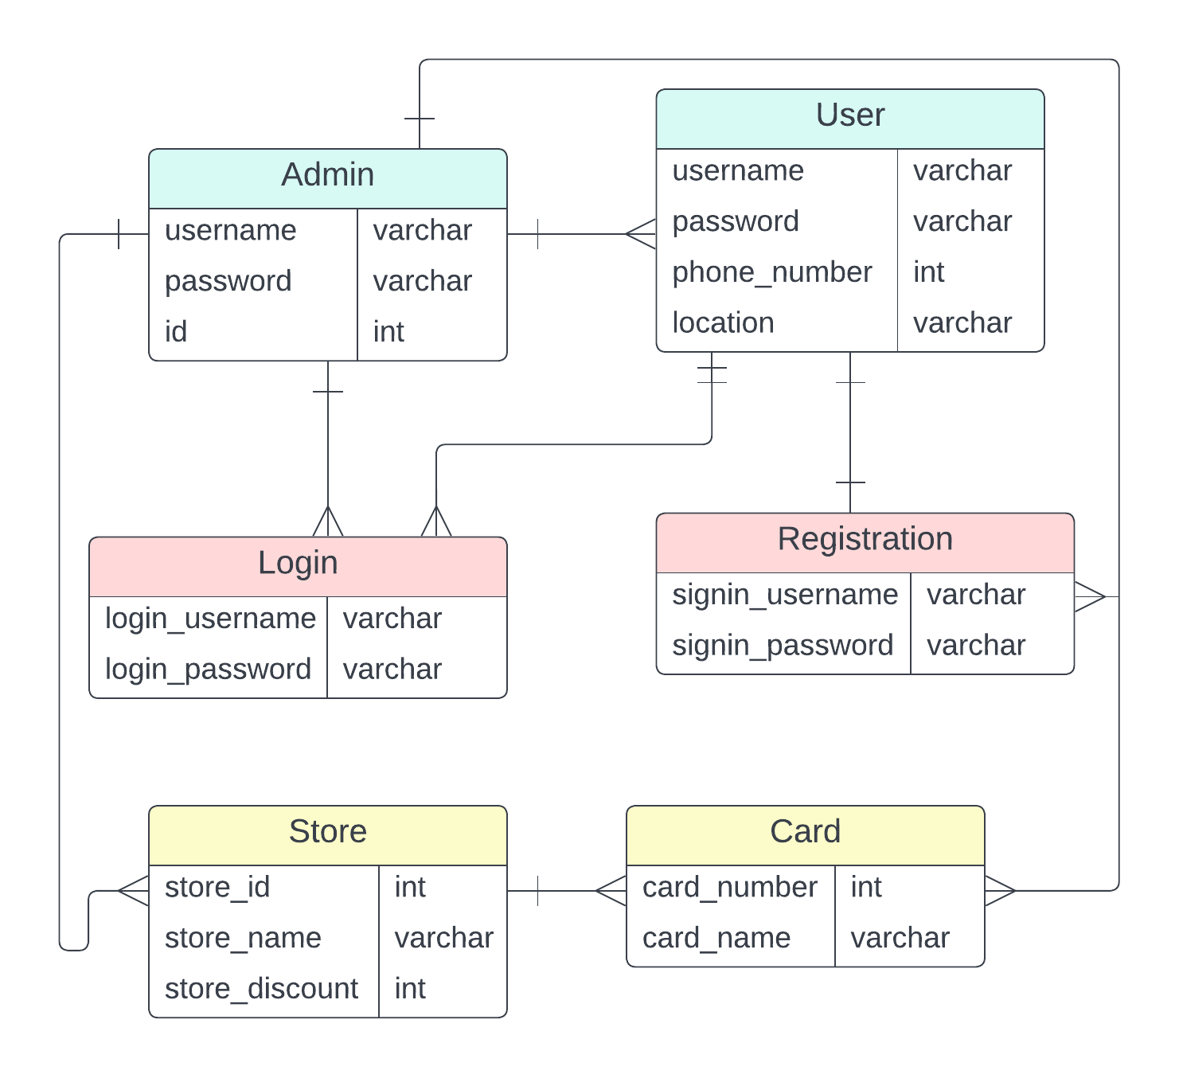

# 8 Application Interfaces

# 9 Data

## 9.1 Data Migration

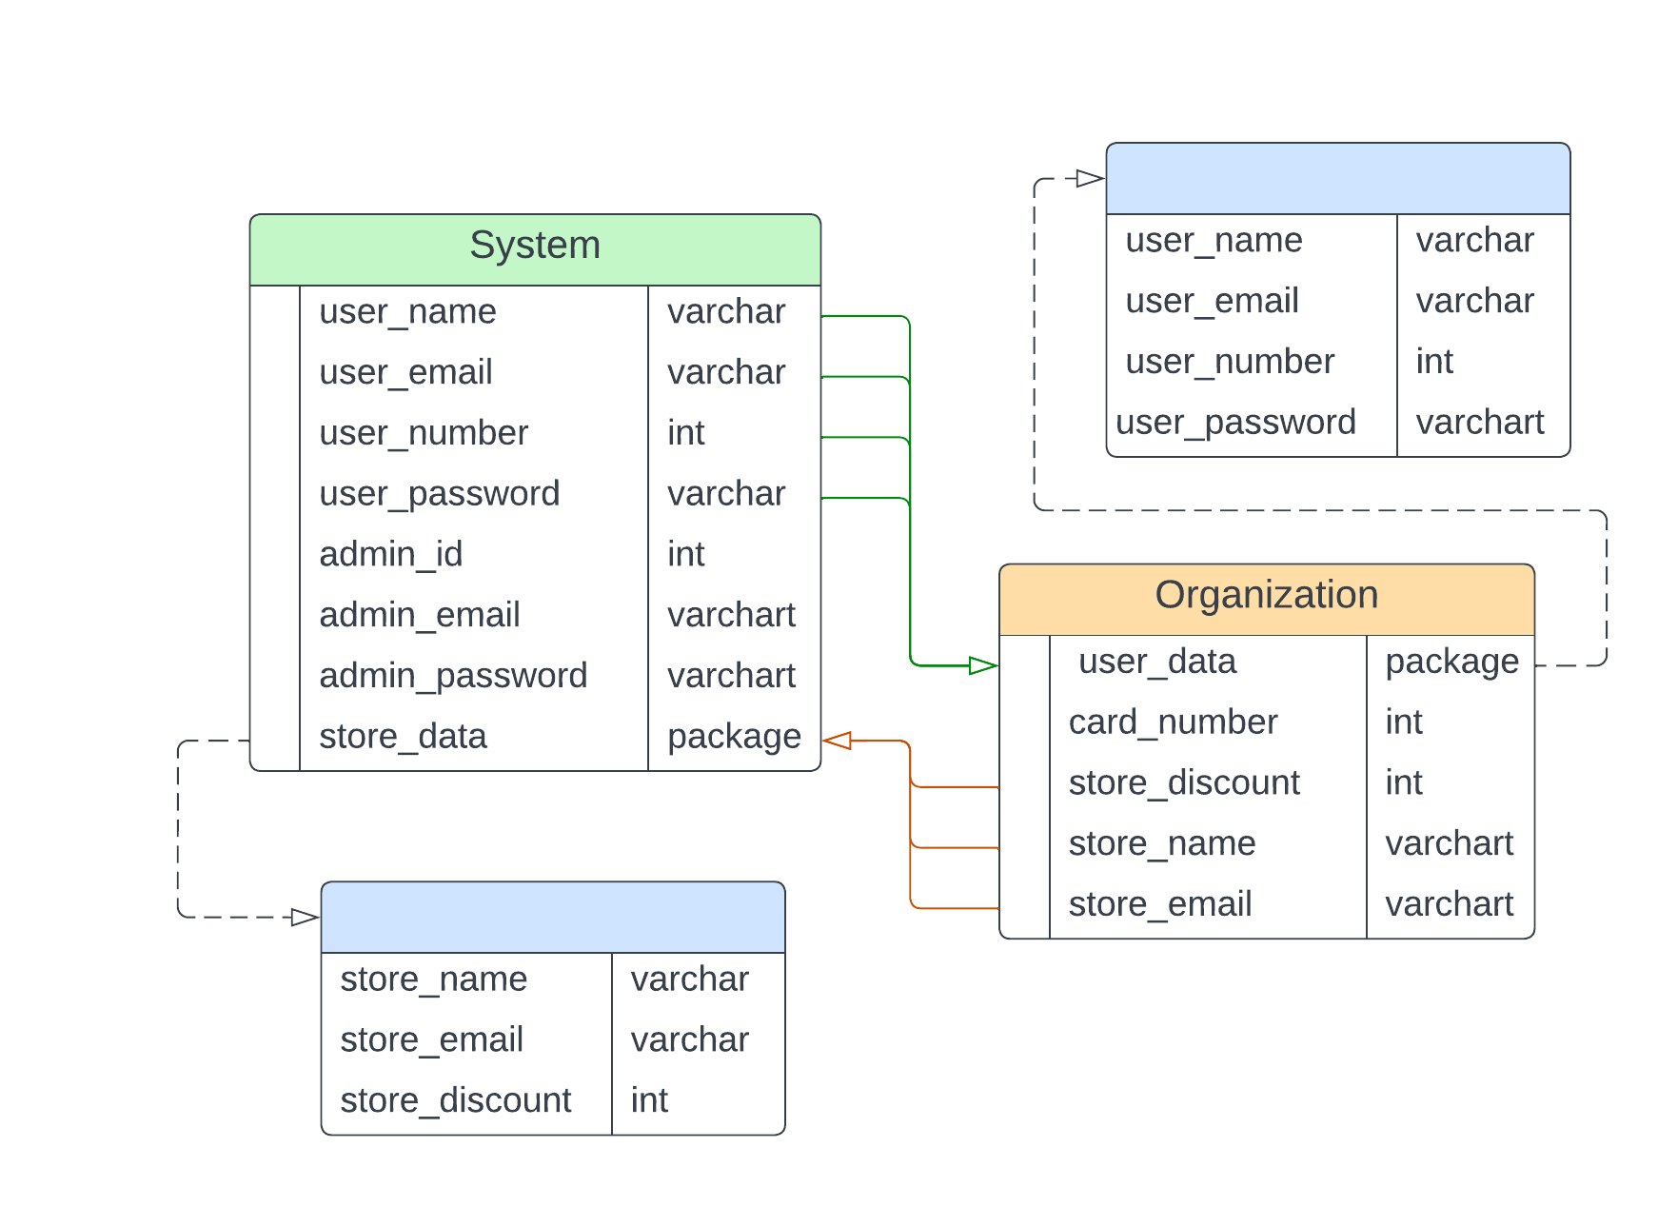

## 9.2 Archiving Policy

# 10 Implementation

We do not implement the code, because of assignment description, consequently we decided to not describe something that is not done.

